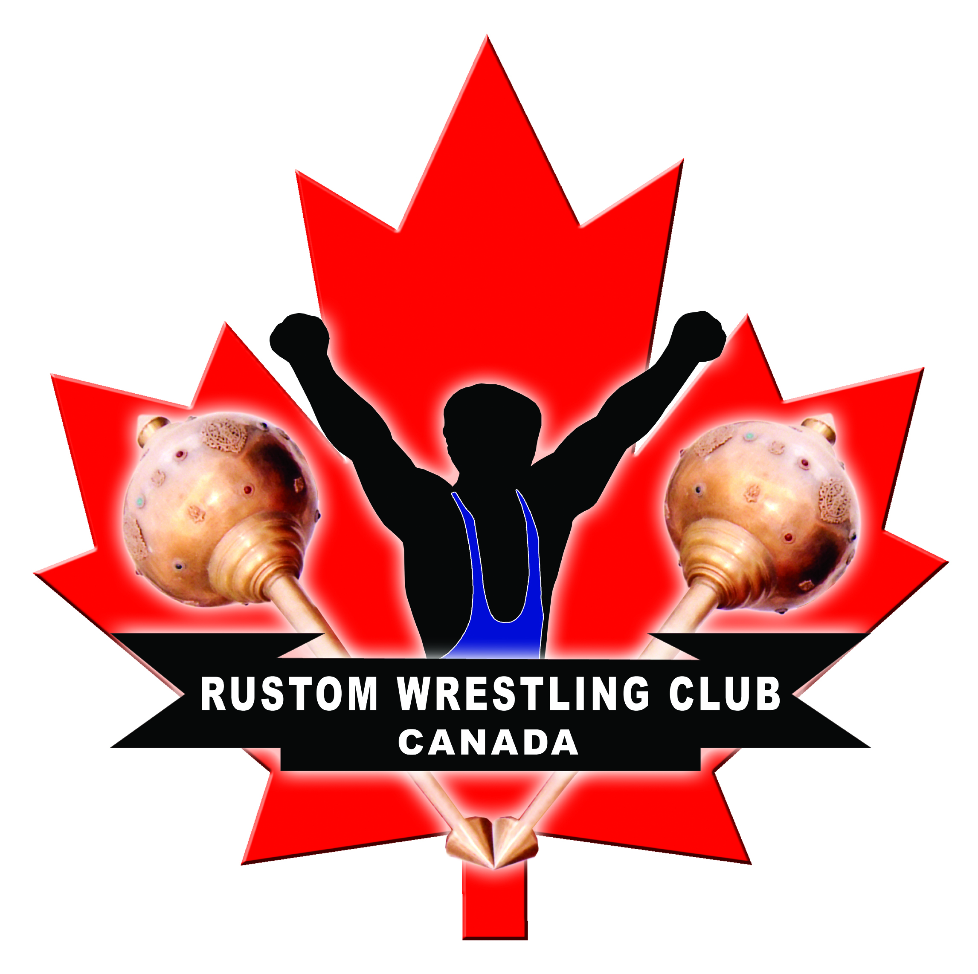
MEMBERSHIP FORM Rustom
Wrestling Club
Start Date :_______________

Membership# ____________
Unit #104 13423 78ave Surrey, BC Beginner □ Intermediate □ Advanced □

Name: ______________________________________________________________________________
(PRINT) (LAST) (FIRST)

Address: _____________________________________________________________________________
(STREET) (CITY) (POSTAL CODE)

Date of Birth:(dd/mm/yyyy): ___ /___ / _____ School: ___________________________________

Parent/ Guardian: _______________________ Ph # _____________________________________

Mobile # _______________________________ Care Card # _______________________________

Email: _________________________________

All memberships are 12 month term memberships | Amount
□ 12 months upfront ($1500) | $ _____________________________
□ Monthly | $ __200.00__ (Monthly fee)

Before signing this document, I have read, understand and hereby agree to the terms and conditions of membership as defined on the back of this membership form and know that it affects my legal rights.

Signature of Athlete: ___________________________________ Date: _________________________

Signature of Parent/Guardian: ___________________________ Date: _________________________

Registration Fee Paid: $__________ Balance Due: $___________ Received By: $ ______________

Method of Payment: □ Check □ Cash □ Credit Card □ EFT □ Scholarship

RUSTOM
WRESTLING CLUB

Scholarship Program:
The Rustom Wrestling Club has a scholarship program available and we encourage people of all income levels to participate in our programs. The Rustom Wrestling Club also welcomes people of all abilities to participate in its programs. We will make all reasonable efforts to include people of all ability or skill level.

Rustom Wrestling Club:
The aim and objective of Rustom Wrestling Club is to produce world class athletes capable of representing Canada at the Olympic platform. Athletes who become wrestlers acquire great, essential traits such as courage, discipline, mental strength. Stepping onto the mat each and every day helps students set goals, work towards achieving them, and finally succeeding. Through this process of achieving their goals students much endure a lot, such as dramatic increase in work ethic, perseverance, physical strength, and hardship but when the athlete succeeds it molds them into an entirely new person, into a Champion (Rustom). As the saying goes “wrestling builds character.”

Mud Wrestling:
In addition to teaching freestyle and Greco/Roman wrestling, Rustom wrestling, Rustom wrestling club will also be teaching weekly classes in traditional Indian mud wrestling commonly referred to as kushti. For more information please contact coach.

MMA Training:
Due to immense public demand and popularity Rustom Wrestling Club will also be providing a home for upcoming MMA athletes who are looking for serious wrestling training. It is a well-known fact by MMA specialists that wrestling is by far the strongest base for any future MMA champion therefore it is essential to learn all the basic and advanced techniques to become an all-around experienced fighter. In addition to this Rustom Wrestling Club provides MMA oriented training such as Tire, sledgehammer, rope unorthodox MMA exercises.

Administration:
No outdoor footwear will be allowed on the wrestling mats at any time. Memberships are not refundable or transferable. All weights and equipment must be put back after use. Each member must respect other club users and behave in an appropriate manner at all times. Rustom Wrestling Club staff reserve the right to rescind the rights of members not complying with the terms and conditions of the membership.

Term Membership:
Term memberships are 12 month memberships that have a start and end date.

Acknowledgement of Risks, Injury & Obligations:
I/We the athlete/parents/guardians understand and acknowledge that Rustom Wrestling sanctioned activities and the sport of wrestling in general have inherent dangers that no amount of care, caution, training, instructions, supervision or expertise can eliminate.

I acknowledge and understand that whilst participating in such activity:
- I may be injured, physically or mentally, or may die;
- My personal property may be lost or damaged;
- Other persons participating in such activity may cause me injury or may damage my property
- I may cause injury to other persons or damage their property
- The conditions in which the activity is conducted may vary without warning
- I may be injured or die or suffer damage to my property as a result of negligence or breach of contract of Rustom Wrestling Association and Rustom Wrestling Club
- There may be no or inadequate facilities for treatment or transportation of me if I am injured
- I assume the risk of and responsibility for any injury, death or property damage resulting from my participation in the activity

Release and Indemnity:
I participate in the activity at my sole risk and responsibility. I release, Indemnify and hold harmless Rustom Wrestling Association & Rustom Wrestling Club, its servants and agents, from and against all and any actions or claims which may be made by me or on my behalf or by other parties for or in respect of or arising out of any injury, loss, damage or death caused to me or my property whether by negligence, breach of contract or in any way whatsoever.

